**Task1**

**Project Title: Academic Management System ( using SQL)**

**1.Database Creation and 2.Data Creation**

Create the StudentInfo table with columns STU_ ID, STU_NAME, DOB, PHONE_NO, EMAIL_ID,ADDRESS. and insert some sample data for StudentInfo table

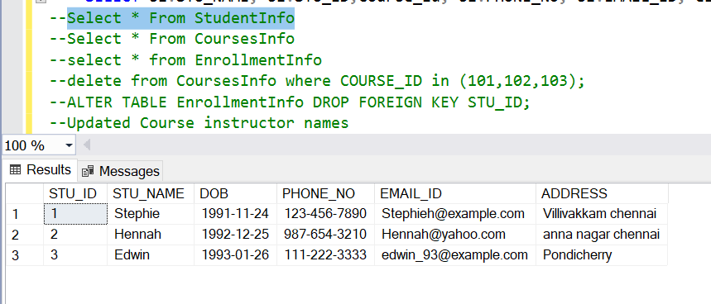

Create the CoursesInfo table with columns COURSE_ID, COURSE_NAME,COURSE_INSTRUCTOR NAME and insert some sample data for CoursesInfo table

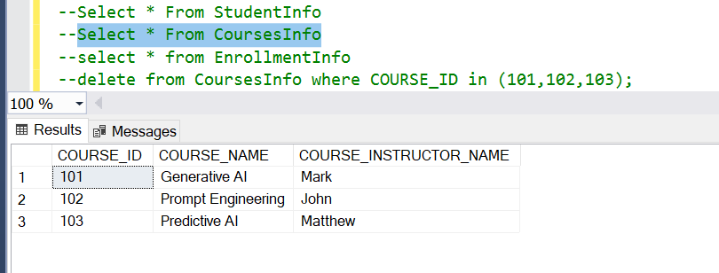

Create the EnrollmentInfo with columns ENROLLMENT_ID, STU_ ID, COURSE_ID, ENROLL_STATUS(Enrolled/Not Enrolled). The FOREIGN KEY constraint in the EnrollmentInfo table references the STU_ID column in the StudentInfo table and the COURSE_ID column in the CoursesInfo table.

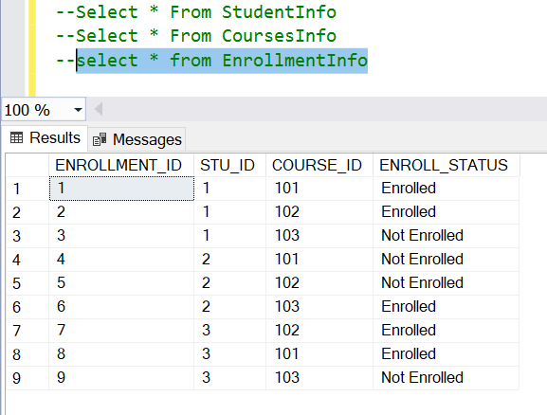

**3. Retrieve the Student Information**

**a) Retrieve student details, such as student name, contact information, and enrollment status**

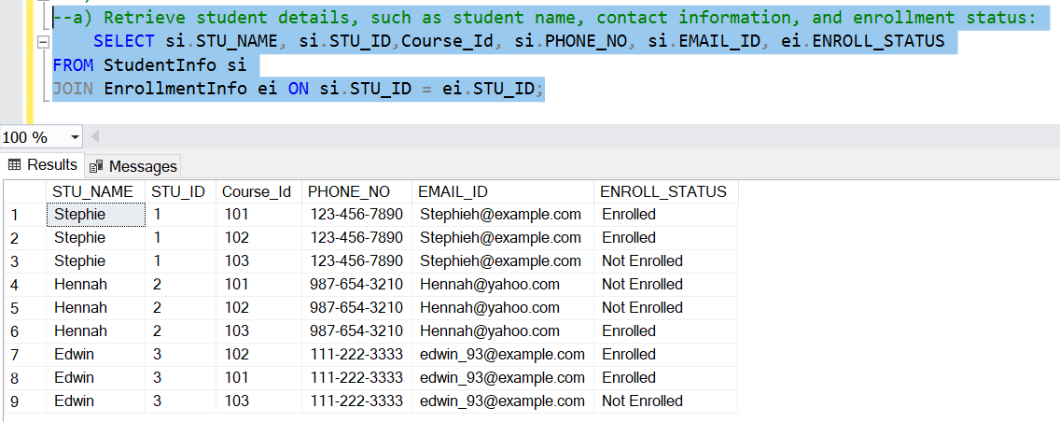

**b) Retrieve a list of courses in which a specific student is enrolled.**

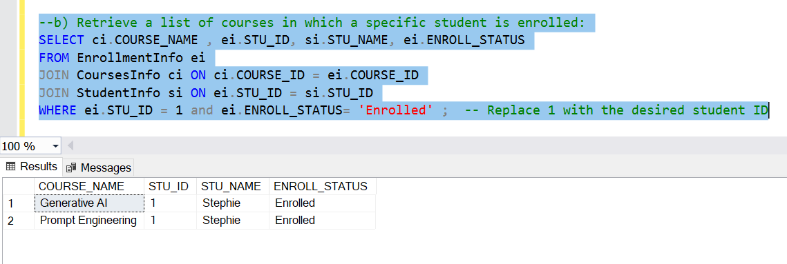

**c) Retrieve course information, including course name and instructor information**

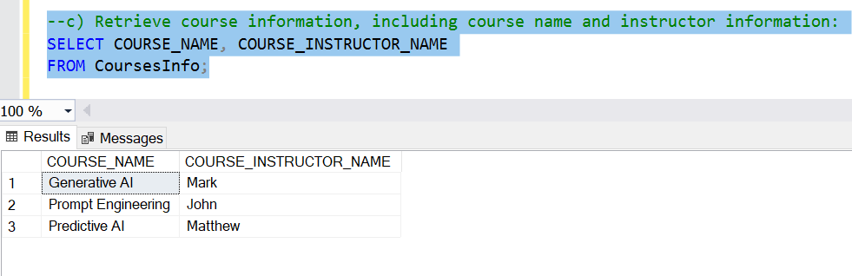

**d) Retrieve course information for a specific course**

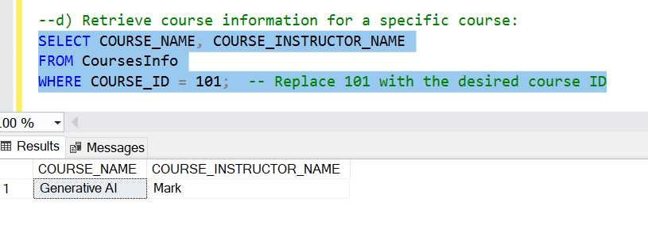

**e) Retrieve course information for multiple courses**

**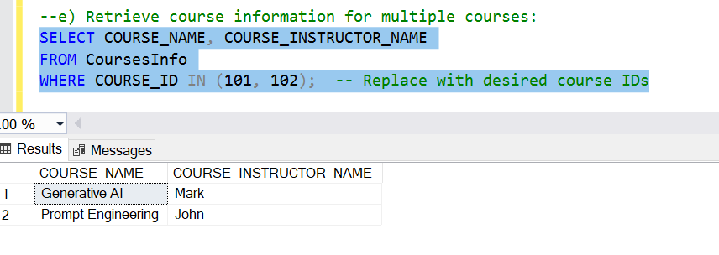  
4. Reporting and Analytics (Using joining queries)**

**a) Number of students enrolled in each course**

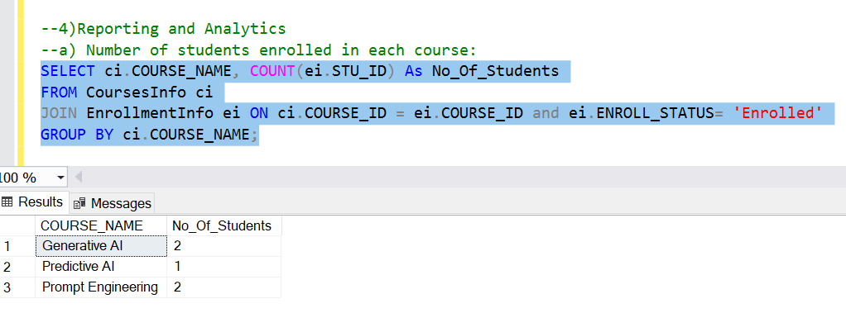

**b) List of students enrolled in a specific course**

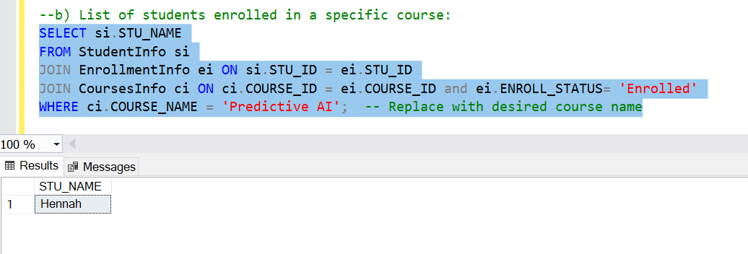

**c) Count of enrolled students for each instructor**

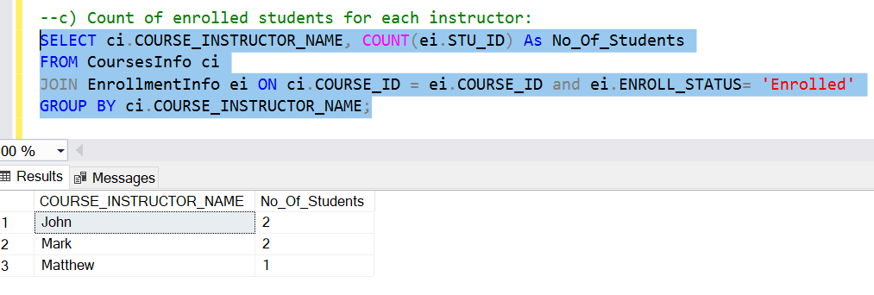

**d) List of students enrolled in multiple courses**

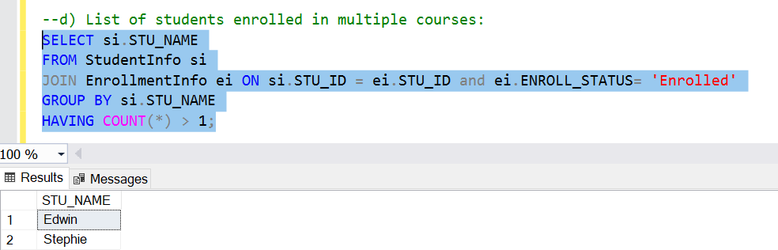

**e) Courses with the highest number of enrolled students((arranging from highest to lowest)**

